DAA LAB ASSIGNMENT – 1
Course: Design and Analysis of Algorithms (DAA)
Student Name: Lavanyadevi K
Student Reg. No: CH.SC.U4CSE24226
Student Department/Class: B. Tech CSE – C (2nd yr)

Q1. Sum of First n Natural Numbers

Question
Write a C program to find the sum of the first n natural numbers using a user-defined function.

Algorithm / Logic
- Read the value of n.
- Use the mathematical formula:
[
\text{Sum} = \frac{n(n+1)}{2}
]
- Print the result.

C Program
#include<stdio.h>
void Sum(int n){
int s = (n*(n+1))/2;
printf("Sum of the natural numbers is %d", s);
}
int main(){
int n;
printf("Enter a natural number: ");
scanf("%d", &n);
Sum(n);
return 0;
}

Output

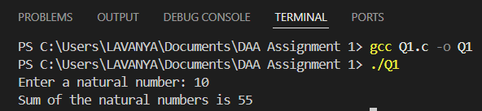

Interpretation
The program uses the direct mathematical formula to compute the sum instead of looping. It reads an input number n, calculates n(n+1)/2, and prints the result efficiently.

Q2. Sum of Squares of First n Natural Numbers

Question
Write a C program to find the sum of squares of the first n natural numbers.

Algorithm / Logic
- Read n.
- Use the formula:
[
\text{Sum} = \frac{n(n+1)(2n+1)}{6}
]
- Print the result.

C Program
#include<stdio.h>
void SumofSquare(int n){
int s = (n*(n+1)*((2*n)+1))/6;
printf("Sum of the square of the natural numbers is %d", s);
}
int main(){
int n;
printf("Enter a natural number: ");
scanf("%d", &n);
SumofSquare(n);
return 0;
}

Output

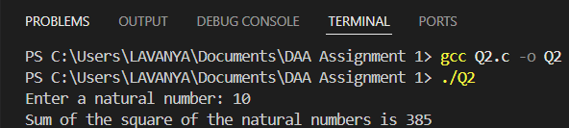

Interpretation
The program uses the direct closed-form formula for the sum of squares, avoiding loops. This makes it fast and simple.

Q3. Sum of Cubes of First n Natural Numbers

Question
Write a C program to find the sum of cubes of the first n natural numbers.

Algorithm / Logic
- Read n.
- Use the identity:
[
1^3 + 2^3 + … + n^3 = \left(\frac{n(n+1)}{2}\right)^2
]
- Print the result.

C Program
#include<stdio.h>
void Sum(int n){
int s = ((n*(n+1))/2)*((n*(n+1))/2);
printf("Sum of the cube of the natural numbers is %d", s);
}
int main(){
int n;
printf("Enter a natural number: ");
scanf("%d", &n);
Sum(n);
return 0;
}

Output

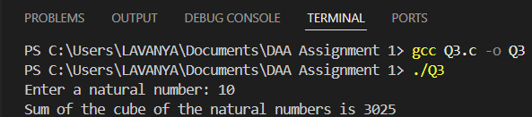

Interpretation
The program uses the mathematical identity that the sum of cubes equals the square of the sum of natural numbers. The computation is efficient and simple.

Q4. Factorial Using Recursion

Question
Write a C program to find the factorial of a number using recursion.

Algorithm / Logic
- If n == 1, return 1.
- Else return n * factorial(n-1).
- Print the result.

C Program
#include<stdio.h>
int factorial(int n){
if(n == 1){
return 1;
}
else{
return n * factorial(n - 1);
}
}
int main(){
int n, result;
printf("Enter a natural number: ");
scanf("%d", &n);
result = factorial(n);
printf("The factorial of the natural number is %d", result);
}

Output

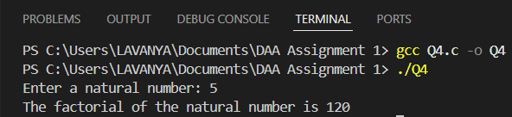

Interpretation
This program uses recursion by repeatedly calling itself until it reaches the base case n == 1. The multiplication of previous values gives the factorial.

Q5. Transpose of a 3x3 Matrix

Question
Write a C program to transpose a 3×3 matrix.

Algorithm / Logic
- Read a 3×3 matrix from the user.
- Swap a[i][j] with a[j][i] for all upper-triangular elements.
- Print the transposed matrix.

C Program
#include <stdio.h>
int main(){
int a[3][3];
printf("Enter 9 values:\n");
for(int i=0; i<3; i++){
for(int j=0; j<3; j++){
scanf("%d", &a[i][j]);
}
}
for(int i=0; i<3; i++){
for(int j=i+1; j<3; j++){
int temp = a[i][j];
a[i][j] = a[j][i];
a[j][i] = temp;
}
}
printf("Transpose:\n");
for(int i=0; i<3; i++){
for(int j=0; j<3; j++){
printf("%d ", a[i][j]);
}
printf("\n");
}
return 0;
}

Output

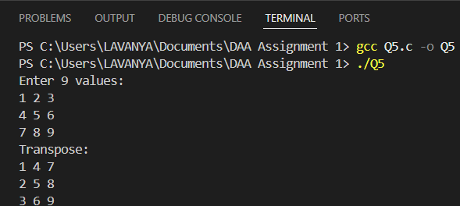

Interpretation
The program performs an in-place transpose by only swapping elements above the diagonal, making it efficient without extra memory usage.

Q6. Fibonacci Series Up to n

Question
Write a C program to print the Fibonacci series up to n using a user-defined function.

Algorithm / Logic
- Initialize a = 0, b = 1.
- Print them.
- Continuously generate next values using c = a + b until c > n.

C Program
#include <stdio.h>
int Fibonacci(int n){
int a = 0, b = 1, c;
printf("%d %d ", a, b);
c = a + b;
while(c <= n) {
printf("%d ", c);
a = b;
b = c;
c = a + b;
}
}
int main() {
int n;
printf("Enter a natural number: ");
scanf("%d", &n);
printf("Fibonacci series up to %d:\n", n);
Fibonacci(n);
return 0;
}

Output

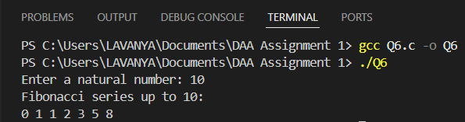

Interpretation
The program prints the Fibonacci numbers iteratively. It stops when the next number exceeds the given limit n.

